University Website Chatbot – Hybrid Design (Buttons + Natural Language)
Objective
Create a chatbot for a university website that combines interactive, button-based navigation with natural language input. Users should be able to explore key topics through guided button selections (e.g., Admissions, Courses, Fees) or type their questions freely. The chatbot will use AI Foundry or Azure OpenAI to scan and understand content from the university’s public website—such as course catalogs, admissions pages, and departmental descriptions—and provide accurate, conversational responses. Whenever possible, responses should include direct links to the relevant pages or sections.
User Interaction Flow
Step 1: Show Main Topics (as Buttons) When the chatbot opens, users are presented with buttons like: - Academic Programs - Admissions - Tuition & Fees - Campus Life & Housing - Ask a Question
Step 2: Subcategory Buttons (Based on Selection) If user selects “Academic Programs”: - Science & Biology Courses - College of Arts & Sciences - Data Science Programs - Show All Majors
If user selects “Admissions”: - How to Apply - International Students - Test Score Requirements
If user selects “Tuition & Fees”: - Out-of-State Tuition - Scholarships for Transfers - Payment Options
If user selects “Campus Life & Housing”: - Student Housing - Sports Programs - Mental Health Support
If user selects “Ask a Question”: A free text input box appears with a prompt like: “Ask me anything about courses, deadlines, campus life…”

Sample Questions the Chatbot Should Handle
Academic Programs - What courses are available for science? - What kind of course can I take in the biology department? - List majors under the College of Arts and Sciences. - Do you offer any data science programs?
Admissions - How do I apply for undergraduate programs? - Is there a deadline for international students? - Can I apply without SAT scores?
Tuition and Fees - What’s the tuition for out-of-state students? - Are there any scholarships for transfer students?
Campus Life and Support - Where can I find mental health resources? - Do you offer student housing for graduates? - What sports are offered on campus?
Implementation Requirements
- Use Azure AI Foundry or OpenAI Studio to create the model response layer.
- Use custom UI or Bot Framework Web Chat to create the button-driven hierarchy.
- Parse user clicks as intents to feed into the AI model or hard-coded responses.
- All responses should link back to the section/page it was sourced from (if possible).
Deliverables
- Hosted chatbot link or embedded sample
- Code repo or notebook used for backend + prompt logic.
- Short README explaining flow, logic, and tools used.

Azure Subscription:
https://azure.microsoft.com/en-us/pricing/purchase-options/azure-account
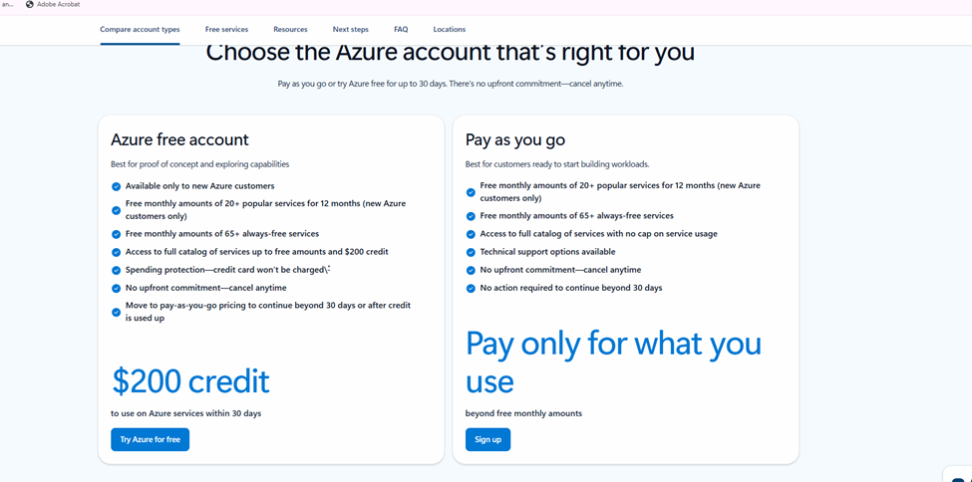

Azure Usage Disclaimer
This chatbot should be created using Azure's free credit.
We are not responsible for any charges beyond the free tier.
Please monitor your usage and delete resources when they are no longer needed.

